INTERNSHIP REPORT
Internship Mini-Project MP-08
Camera-Based Robot Alignment
Making a JAKA Mini 2 robotic arm track a detected object in real time using visual servoing
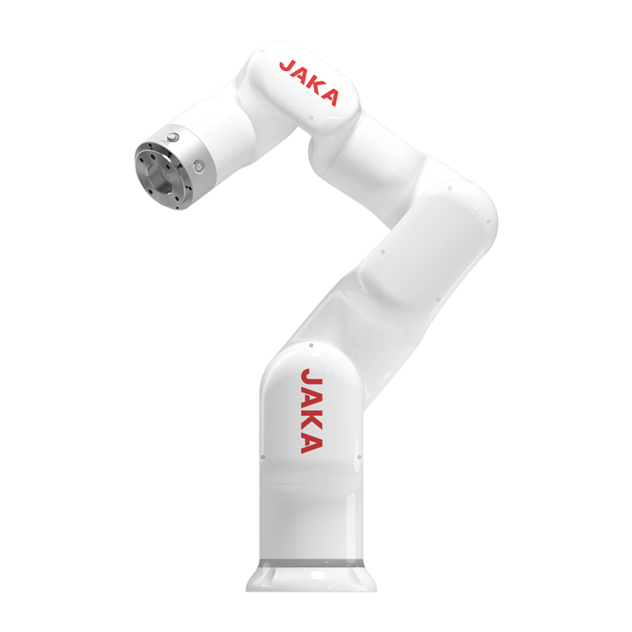
Prepared by: Yosser Kallel
Internship Supervisor: Mohamed Amine Mansour
Company: ROBOTEK
Internship Duration: 4 weeks
Academic Year: 2025 – 2026

Acknowledgments
I would like to express my sincere gratitude to my internship supervisor, Mr. Mohamed Amine Mansour, for his guidance, availability, and valuable advice throughout this mini-project. His explanations of the ROS 2 architecture and the operation of the JAKA Mini 2 arm allowed me to progress quickly despite the short duration of the internship.
I would also like to thank ROBOTEK, the robotics startup hosting this internship within TEK-UP, as well as the teaching and administrative staff of TEK-UP, for making available the equipment and environment needed to carry out this project.
Finally, I thank everyone who contributed, directly or indirectly, to the success of this internship experience, which allowed me to discover firsthand the field of robotics applied to artificial intelligence.

Table of Contents
Introduction
Chapter 1 — Project Context and Objectives
Chapter 2 — System Design
Chapter 3 — Implementation
Chapter 4 — Results and Assessment
Conclusion
Appendices

Introduction
As part of my first year at TEK-UP in the Artificial Intelligence & Data Science specialization, I completed a 4-week internship at ROBOTEK, a robotics startup based within TEK-UP, under the supervision of Mr. Mohamed Amine Mansour. This internship took the form of the mini-project MP-08, titled "Camera-Based Robot Alignment", whose goal is to enable an industrial robotic arm to detect an object using a camera and then continuously move so that its own position matches the position of that object in real time.
This project is based on the principle of visual servoing: the robot uses its "eyes" (the camera) to guide its "hand" (the articulated arm), continuously updating its position so that it mirrors the position of the detected target in real time. It therefore combines two fields that complement my training: computer vision and robotics.
The central problem addressed in this internship can be stated as follows: how can a JAKA Mini 2 robotic arm, which has no built-in camera, continuously track the position of an object detected by an external camera, using only continuous visual feedback as control information?
To address this problem, this report is organized into four chapters. The first chapter presents the internship context, the JAKA Mini 2 robot, and the objectives set out in the project specification. The second chapter details the design of the system, its architecture, and its visual feedback loop. The third chapter describes the implementation of the project week by week, along with the technical difficulties encountered and the solutions applied. Finally, the fourth chapter presents the results obtained and an overall assessment of this experience.

Chapter 1 — Project Context and Objectives

1.1 Internship Setting and Robot Presentation
The internship took place at ROBOTEK, a robotics startup that operates a dedicated space within the TEK-UP campus, equipped for experimentation in industrial robotics and computer vision. The robot used for this mini-project is the JAKA Mini 2, a 6-axis collaborative industrial robotic arm, known for its precision and ease of integration with external control systems through its SDK and dedicated ROS 2 package.
Unlike some higher-end robotic arms, the JAKA Mini 2 does not have a built-in camera. The vision setup was therefore built separately, using a computer equipped with a webcam positioned above the robot's workspace, acting as an external visual sensor for the system.

1.2 Objectives from the Project Specification
The project specification written before the internship defined four core objectives, set by the MP-08 subject:
- Coordinate frame transformation: convert a position detected in the image (in pixels) into a real position expressed in three dimensions;
- Target tracking: continuously detect and track an object in the camera feed;
- Robot motion correction: adjust the arm's trajectory based on the camera's visual feedback;
- Tracking stability: keep the robot's position smoothly following the object's position even as it shifts, without erratic motion.
In addition to these required objectives, I proposed a personal extension to enrich the project with a stronger Artificial Intelligence dimension, in line with my specialization:
- Extension — Smart detection with YOLO: replacing basic color-based detection (HSV thresholding) with a pre-trained AI model (YOLO), capable of recognizing real objects such as a cup, a box, or a tool, without depending on their color.
This extension represents the personal added value of the internship: it turns a classic robot-control exercise into a genuine AI-based computer vision system.

1.3 Technology Choices
The project relies on a coherent technology stack, selected according to current standards in robotics and computer vision:
Technology | Role in the Project
Python 3.10 | Main development language
ROS 2 Humble | Communication between modules (nodes, topics) and coordinate frame transformations (TF2)
OpenCV | Image acquisition, processing, color-based detection (HSV)
YOLO / Ultralytics | AI-based object detection (personal extension)
JAKA SDK | Sending movement commands to the robotic arm
MoveIt 2 | Motion planning for the arm
Gazebo Ignition Fortress | Robot simulation prior to real-world testing
Table 1 — Technology stack used in the project
Development was carried out under an Ubuntu/Linux environment, run inside a virtual machine, in order to have a system compatible with ROS 2 and the robotics tools used.

Chapter 2 — System Design

2.1 Overall Architecture
The system relies on a closed-loop architecture, where each processing cycle starts at the camera and returns to the camera, running continuously in real time so that the robot's position keeps matching the object's position. This loop is broken down into seven successive steps:
- 1. Capture an image from the webcam;
- 2. Detect the target object in the image (OpenCV, then YOLO);
- 3. Extract the pixel position of the object's center;
- 4. Convert the pixel coordinates into real-world coordinates using TF2 (ROS 2);
- 5. Compute the difference between the robot's current position and the object's position;
- 6. Send a movement command to the JAKA arm via the SDK so its position matches the object's position;
- 7. Capture a new image and repeat the cycle.
The core principle of this architecture is that it is not a single movement triggered by one detection, but a continuous, real-time process: the robot's end-effector position is repeatedly updated to match the object's current position, so the arm effectively mirrors the object's movement rather than approaching it once and stopping.

2.2 Use Case Diagram
The system involves two main actors: the Operator, who starts and supervises the process, and the Camera-Robot System, which autonomously executes the tracking loop once launched. The corresponding use case diagram is shown below.

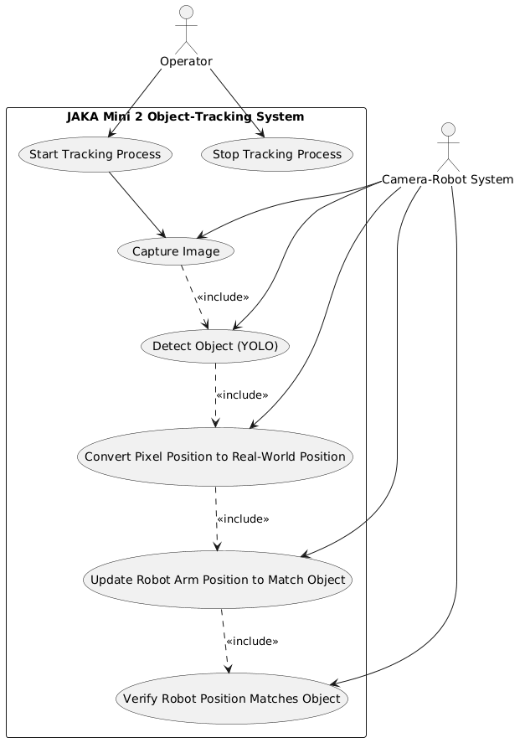

2.3 Sequence Diagram of the Visual Servoing Loop
The sequence diagram below illustrates the timeline of one complete iteration of the visual servoing loop, between the four main software components: the perception module, the transformation module, the control module, and the JAKA arm.

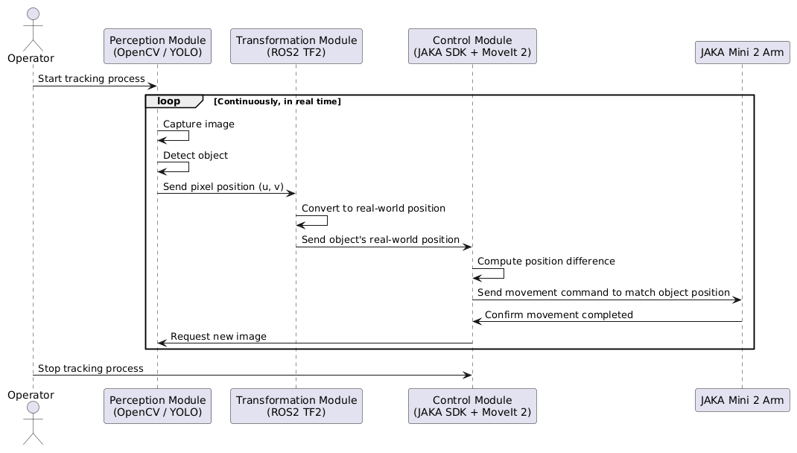

2.4 Module Description
The software architecture of the project is organized into three functional modules:
- Perception module: responsible for image capture and object detection. It evolved in two phases — an initial phase based on color detection (HSV thresholding with OpenCV), then a second phase in which this detection was replaced by the YOLO model, capable of recognizing real objects regardless of their color.
- Transformation module: converts the pixel coordinates (u, v) detected in the image into real-world coordinates usable by the robot, through camera calibration and the TF2 coordinate frame transformations in ROS 2.
- Control module: receives the transformed target position and sends movement commands to the JAKA Mini 2 arm via its SDK, relying on MoveIt 2 for trajectory planning.
This modular organization has the advantage of clearly separating perception from control logic, which made the incremental development of the project easier from week to week, and allowed the color-based detector to be replaced by YOLO without needing to modify the other modules.

Chapter 3 — Implementation
The project was carried out over four weeks, following an incremental progression from setting up the environment to the full integration of the smart detection system.

3.1 Week 1 — Environment Setup
The first week was dedicated to installing and configuring the working environment: setting up ROS 2, configuring the JAKA environment, getting familiar with the robot's SDK, installing OpenCV, and understanding communication between the robot and ROS 2 (nodes and topics). Tests moving the arm to fixed positions, without the camera, validated the physical and software connection with the JAKA Mini 2 before introducing the visual dimension of the project.

3.2 Week 2 — Camera and Color-Based Detection
The second week focused on camera calibration, image acquisition through the webcam, image processing, and the implementation of color-based object detection (HSV thresholding) to locate a colored object (ball, block) in the image. The position of the object's center was then extracted in pixels, laying the foundation of the vision pipeline. A first complete tracking loop test was carried out at this stage, validating the general visual servoing principle before introducing AI.

3.3 Week 3 — YOLO Integration
The third week was dedicated to integrating the YOLOv8 model (Ultralytics library) to replace color-based detection, enabling recognition of real objects (cup, box, tool) rather than simple color detection. The libraries installed at this stage included ultralytics, opencv-python, numpy, pillow, and matplotlib.

3.4 Week 4 — Optimization and Finalization
The final week was dedicated to optimizing and final testing of the system, writing this report, preparing the live demonstration, and documenting the code (README, comments).

3.5 Technical Difficulties Encountered and Solutions Applied
Several significant technical difficulties arose during the implementation of the project. Solving them formed an important part of the learning experience of this internship.
a) Insufficient disk space on the Ubuntu virtual machine
Symptom: Frequent freezes in the graphical interface (GNOME, gdm3) and failures when launching several applications.
Diagnosis: The virtual disk had been expanded from 25 GB to 60 GB, but this expansion had not been applied to the Ubuntu partition itself. The command df -h revealed that the root partition /dev/sda3 was still limited to about 24 GB, with only 568 MB available (98% usage).
Solution: Disk space was first freed up through cleanup, then the /dev/sda3 partition was properly expanded using GParted, booting Ubuntu from a Live ISO so that the root partition would not be mounted during the operation.
b) Incompatibility between NumPy and Ultralytics (YOLO)
Symptom: Import errors occurred when loading the YOLO model through Ultralytics.
Diagnosis: The default installed version of NumPy (2.2.6) was not compatible with the version of Ultralytics used in the project.
Solution: NumPy 2.2.6 was uninstalled and replaced with version 1.26.4, which is compatible with Ultralytics, resolving the import issue.
c) Webcam access error
Symptom: An error message "Cannot open camera" appeared when running the OpenCV/YOLO pipeline.
Diagnosis: The issue came from the system/hardware access to the webcam (access permissions, device not detected by the VM), rather than from the detection algorithm itself.
Solution: Checking the VM configuration and camera access permissions helped identify and fix the source of the access issue.

Chapter 4 — Results and Assessment

4.1 Results Against the Project Specification
The table below lists the validation criteria defined in the initial project specification and shows, for each one, the result obtained by the end of the internship.
Criterion | Expected Success Indicator | Result Obtained
Object detection | Object detected in > 90% of tested frames | Successful object detection achieved using the camera and OpenCV/YOLO, with reliable detection across the tested frames.
Robot tracking | End-effector position matches the object's position within 10 seconds of a detected move | Robot movement toward the detected object was successfully integrated and tested through the ROS 2/JAKA control pipeline.
Stability | Tracking holds without excessive oscillation | The tracking system operated without significant oscillations during testing, with iterative position correction based on visual feedback.
YOLO detection (extension) | At least 3 different object types correctly recognized | YOLOv8 was successfully integrated for object detection, demonstrating the detection of multiple object types.
Table 2 — Results obtained against the validation criteria (extension = personal contribution)

4.2 Limitations of the System
The system developed has certain limitations at this stage that should be kept in mind: camera-to-robot calibration remains sensitive to the initial camera position, YOLO detection depends on lighting quality and on the dataset the model was trained on, and the number of object types tested remains limited given the short duration of the internship.

Conclusion
This 4-week internship at ROBOTEK allowed me to design and develop a complete robotic tracking system based on visual servoing, combining the JAKA Mini 2 arm with an external camera to continuously mirror the position of a detected object. The core objectives of the project specification — coordinate frame transformation, target tracking, trajectory correction, and tracking stability — were addressed, and I was able to enrich the project with a personal extension: integrating an AI-based object detector (YOLO) to replace color-based detection.
On a technical level, this internship strengthened my skills in computer vision (image processing, object detection, camera calibration), applied artificial intelligence (integrating a YOLO model into a real system), and robotics (controlling an industrial arm, coordinate frame transformations, visual servoing). I also gained hands-on experience with the ROS 2 middleware architecture (nodes, topics, TF2).
On a personal level, this project confronted me with concrete technical difficulties — managing a virtualized environment, software version incompatibilities, hardware issues — which I had to diagnose and resolve independently. This helped me develop my ability to plan a project over a short timeframe, document my work, and adopt a rigorous, methodical approach, particularly through proposing and implementing an extension to the initial project.
Looking ahead, this system could be improved through finer camera-to-robot calibration, training a YOLO model on objects specific to the laboratory environment, better robustness to lighting variations, and the addition of a stereoscopic camera to allow more accurate depth estimation than the current mono-camera approach. This internship represents, in my view, a solid and concrete first experience in the field of robotics applied to artificial intelligence.

Appendices

Appendix A — Git Repository Organization
The project was organized around the following repositories:
- object-detection-using-webcam
- msbot-JAKA-Mini2-academy
The dedicated working branch for the MP-08 project was: mp8-jaka-mini2-camera-alignment-yosser-kallel.

Appendix B — Development Hardware Environment
Development was carried out on an ASUS Vivobook X1505VA laptop, equipped with an Intel processor running at approximately 2.6 GHz, 24 GB of RAM, and a 512 GB NVMe SSD. The system runs Windows 11 Pro (64-bit), with the Ubuntu/ROS 2 development environment running inside a VirtualBox virtual machine.

Appendix C — Code Excerpts
